Lab 1 :OOP LAB
Objective
By the end of these labs, you will:
- Understand why classes are better than dictionaries for structured data
- Build and use class hierarchies with inheritance
- Trace how Python resolves attributes across objects and classes

Part 1 — Simple Class vs Dictionary Comparison

Learning Goal
Understand the limitations of dictionaries and the benefits of using classes.

Part A — Using Dictionary

Step 1: Create a student using a dictionary

student = {
"name": "Aina",
"age": 6,
"introduce": lambda: print("Hi, I am Aina")
}

student["introduce"]()

Step 2: Add another student

student2 = {
"name": "Ali",
"age": 7,
"introduce": lambda: print("Hi, I am Ali")
}

Discussion Questions
- What happens if we forget a key?
- How do we ensure consistency across students?
- Can behavior be reused easily?

Part B — Using Class

Step 3: Convert dictionary into a class

class Student:
def __init__(self, name, age):
self.name = name
self.age = age

def introduce(self):
print(f"Hi, I am {self.name}")

Step 4: Create multiple students

s1 = Student("Aina", 6)
s2 = Student("Ali", 7)

s1.introduce()
s2.introduce()

Expected Outcome
- Cleaner structure
- Reusable behavior
- Less duplication

Part 2 — Create Class Hierarchies

Learning Goal
Learn how inheritance enables code reuse and extension.

Step 1: Create a base class

class Person:
def __init__(self, name):
self.name = name

def introduce(self):
print(f"My name is {self.name}")

Step 2: Create child classes

class Student(Person):
def study(self):
print(f"{self.name} is studying")

class Teacher(Person):
def teach(self):
print(f"{self.name} is teaching")

Step 3: Create objects

student = Student("Aina")
teacher = Teacher("Mr. Adam")

student.introduce()
student.study()

teacher.introduce()
teacher.teach()

Observation Tasks
- Which methods come from Person?
- Which methods belong only to the child class?

Expected Outcome
- You should see clear inheritance
- Reduced code duplication
- Logical class structure

Part 3 — Attribute Resolution Tracing

Learning Goal
Understand how Python finds attributes and methods.

Step 1: Create base and child classes

class School:
name = "Anak2U"

class Student(School):
def __init__(self, name):
self.name = name

Step 2: Access attributes

s = Student("Aina")

print(s.name)
print(Student.name)
print(School.name)

Step 3: Trace the lookup order
Write down the lookup steps:
- Instance (s)
- Class (Student)
- Parent class (School)

Step 4: Remove instance attribute

del s.name
print(s.name)

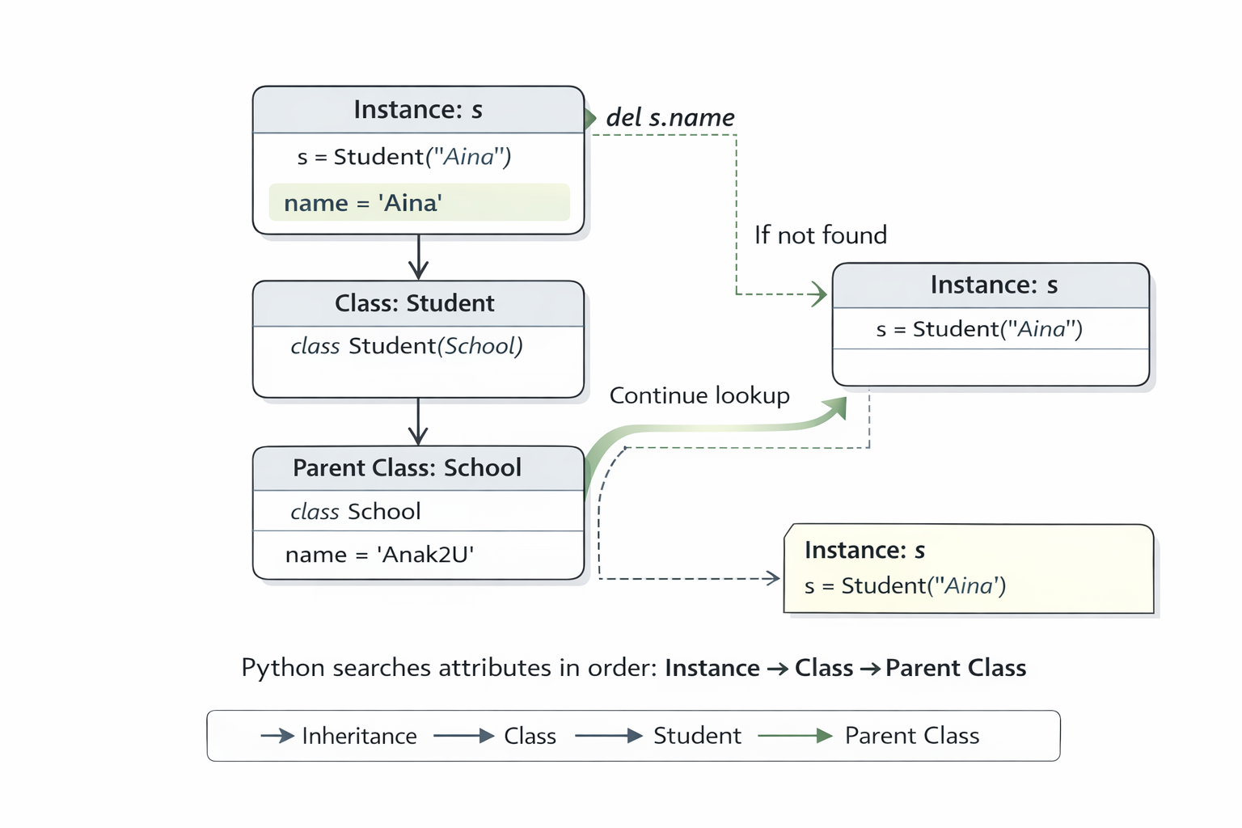

Discussion Questions
- Why does the output change?
- Where did Python find name after deletion?
- What happens if School.name is removed?

Expected Outcome
- Clear understanding of attribute lookup
- Confidence debugging attribute-related bugs

Bonus Challenge (Optional)

print(Student.__mro__)

- What does MRO mean?
- Why is this order important?

Wrap-Up Questions
- When should you prefer classes over dictionaries?
- How does inheritance simplify your design?
- Why is attribute lookup important for debugging?

Conclusion
- Classes provide structure and consistency: Compared to dictionaries, classes group data and behavior together, reducing errors, duplication, and inconsistency as programs grow.
- Inheritance promotes reuse and clarity: Using a base class (Person) allowed shared behavior to be written once, while child classes (Student, Teacher) added their own responsibilities cleanly.
- Python follows a predictable attribute lookup order: Attributes are resolved in the order Instance → Class → Parent Class, helping explain unexpected behavior when attributes are overridden or deleted.
- Understanding lookup order improves debugging skills: Tracing where Python finds attributes makes it easier to diagnose bugs related to missing or shadowed variables.
- Good OOP design scales better than ad-hoc structures: The lab showed how moving from dictionaries to classes creates code that is easier to extend, reason about, and maintain.

Lab 2: Person / Employee + Override Methods + __str__ & __repr__

Objective
By the end of this lab, you will be able to:
- Build a base class (Person) and a subclass (Employee)
- Override methods in a subclass
- Implement __str__ (user-friendly) and __repr__ (developer/debug-friendly)

Part 0 — Setup
- Create a file named: lab_person_employee.py
- Run your code using:
python lab_person_employee.py

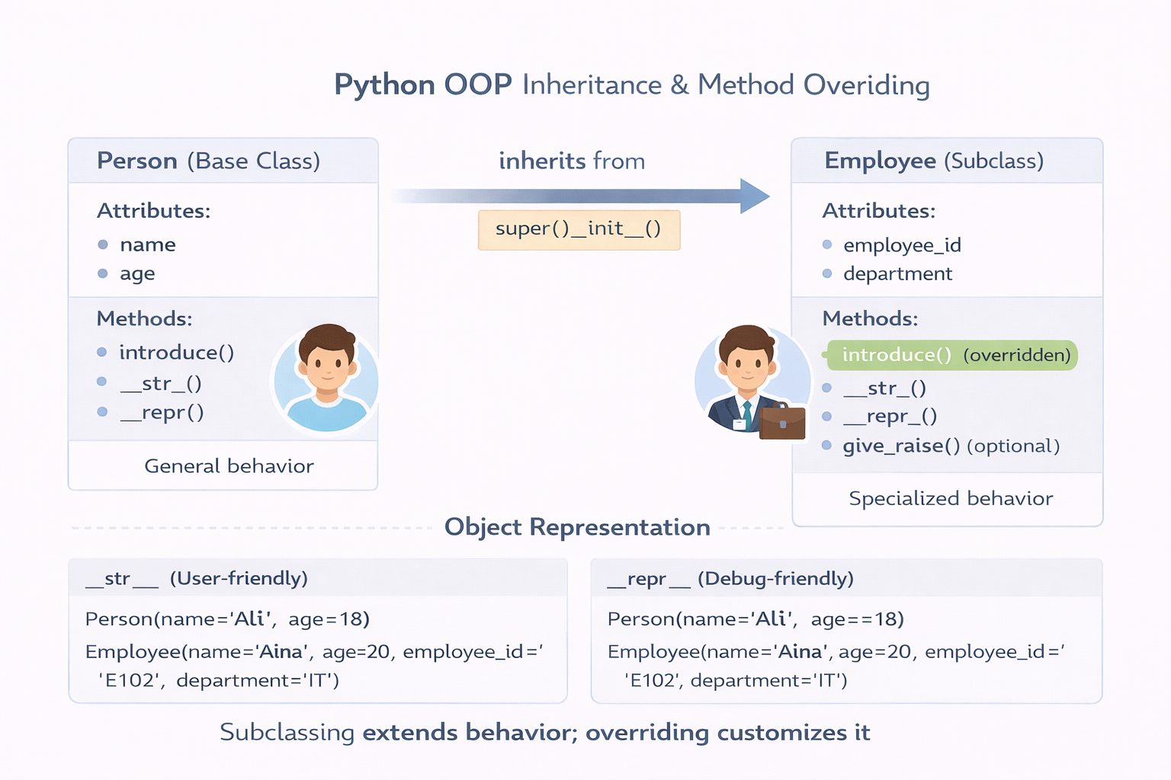

Part 1 — Build the Person Class

Step 1: Create the class skeleton
Task: Create a class Person with:
- Attributes: name, age
- A method: introduce() that prints a greeting
class Person:
"""Represents a person with a name and age."""

def __init__(self, name, age):
self.name = name
self.age = age

def introduce(self):
print(f"Hi, I’m {self.name} and I’m {self.age} years old.")

Step 2: Test Person
Create a Person instance and call introduce().
p = Person("Aina", 20)
p.introduce()
Expected behavior example
Hi, I’m Aina and I’m 20 years old.

Part 2 — Build the Employee Class (Inheritance)

Step 3: Create Employee that inherits from Person
Task: Create a subclass Employee(Person) with additional attributes:
- employee_id
- department
class Employee(Person):
"""Represents an employee who is also a person."""

def __init__(self, name, age, employee_id, department):
super().__init__(name, age)
self.employee_id = employee_id
self.department = department

Step 4: Test Employee
Create an Employee and verify it still has access to introduce().

e = Employee("Aina", 20, "E102", "IT")
e.introduce()

Part 3 — Override a Method

Step 5: Override introduce() in Employee
Task: Employee.introduce() should include employee details.
def introduce(self):
# method overriding + optional reuse using super()
# super().introduce() # uncomment if you want base greeting first
print(
f"Hi, I’m {self.name} (ID: {self.employee_id}) from {self.department}, "
f"and I’m {self.age} years old."
)

Example output
Hi, I’m Aina (ID: E102) from IT, and I’m 20 years old.

Requirements:
- Must use method overriding (same method name)
- Must call super() optionally (recommended)

Part 4 — Implement __str__ and __repr__

Step 6: Add __str__ to Person
Task: Implement __str__ so printing an object is readable.
Example

def __str__(self):
# user-friendly printing
return f"Person(name='{self.name}', age={self.age})"

p = Person("Ali", 18)
print(p)

Expected output:
Person(name='Ali', age=18)

Step 7: Add __repr__ to Person
Implement __repr__ as a debugging-friendly representation.
def __repr__(self):
# developer/debug-friendly printing
return f"Person(name='{self.name}', age={self.age})"

print(repr(p))

Recommended format:
Person(name='Ali', age=18)

In small projects, __repr__ can match __str__, but conceptually:
- __str__ → for users
- __repr__ → for developers/debugging

Step 8: Add __str__ and __repr__ to Employee
Task: When you print Employee, it should include employee fields too.
def __str__(self):
return (
f"Employee(name='{self.name}', age={self.age}, "
f"employee_id='{self.employee_id}', department='{self.department}')"
)

def __repr__(self):
return (
f"Employee(name='{self.name}', age={self.age}, "
f"employee_id='{self.employee_id}', department='{self.department}')"
)

Example
e = Employee("Aina", 20, "E102", "IT")
print(e)
print(repr(e))

Expected output:
Employee(name='Aina', age=20, employee_id='E102', department='IT')
Employee(name='Aina', age=20, employee_id='E102', department='IT')

Final Test Script
At the bottom of the file, add:

def main():
p = Person("Ali", 18)
print(p)
print(repr(p))
p.introduce()

print("-" * 40)

e = Employee("Aina", 20, "E102", "IT")
print(e)
print(repr(e))
e.introduce()

if __name__ == "__main__":
main()

Bonus Challenge (Optional)
- Add give_raise(percent) method to Employee
def give_raise(self, percent):
"""Bonus method example: just prints raise info (no salary field in this lab)."""
if percent <= 0:
print("Raise percent must be positive")
return
print(f"{self.name} received a {percent}% raise (demo only).")

- Add validation:
  - age must be positive

def __init__(self, name, age):
if age <= 0:
raise ValueError("age must be positive")
self.name = name
self.age = age

- Add a to_dict() method that returns a dictionary representation

def to_dict(self):
return {
"name": self.name,
"age": self.age,
"employee_id": self.employee_id,
"department": self.department,
}

# Bonus tests
e.give_raise(10)
print(e.to_dict())

Conclusion
- Inheritance enables reuse and extension: Employee reused the structure and behavior of Person while adding employee-specific data, demonstrating a clean is-a relationship.
- Method overriding customizes behavior: Overriding introduce() showed how subclasses can change or extend parent behavior while keeping the same method interface.
- super() supports safe extension: Using super().__init__() ensured parent initialization logic was preserved, reducing duplication and bugs.
- __str__ and __repr__ improve clarity: Implementing both methods made objects readable for users and precise for developers during debugging.
- Well-designed classes are easier to test and extend: Adding validation, bonus methods, and to_dict() demonstrated how good class design scales naturally.

Lab 3 — Mini Banking System
OOP + Shelve + Introspection

Learning Goals
By the end of this lab, you will be able to:
- Build a small object-oriented banking system
- Store and retrieve objects using shelve
- Inspect objects dynamically using Python introspection tools

File Setup
Create one file:
lab_mini_system.py
Run the program with:
python lab_mini_system.py

Mini Banking System Overview
You will build:
- Account (base class)
- SavingsAccount and CurrentAccount (subclasses)
- Bank (manager + persistence)
- Introspection helper function
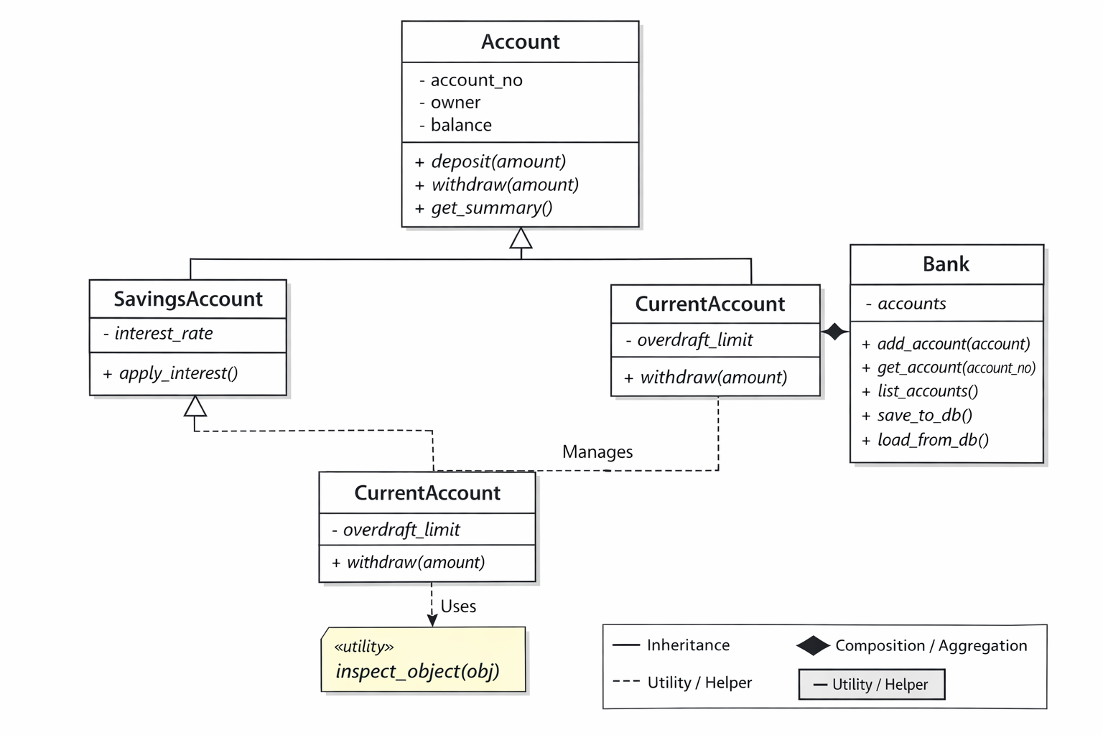

Part 1 — Core Classes (OOP Design)

Step 1 — Create the Account Base Class

What this class does
- Stores account number, owner, balance
- Supports deposit, withdraw, and summary

class Account:
def __init__(self, account_no, owner, balance=0.0):
self.account_no = account_no
self.owner = owner
self.balance = balance

def deposit(self, amount):
if amount > 0:
self.balance += amount

def withdraw(self, amount):
if amount <= self.balance:
self.balance -= amount
else:
print("Insufficient funds")

def get_summary(self):
return f"{self.account_no} | {self.owner} | Balance: {self.balance}"

Quick Test
a = Account("A100", "Aina", 100)
a.deposit(50)
a.withdraw(30)
print(a.get_summary())
Expected output:
A100 | Aina | Balance: 120

Part 2 — Create Subclasses

Step 2A — SavingsAccount

What it adds
- Interest rate
- Method to apply interest
class SavingsAccount(Account):
def __init__(self, account_no, owner, balance, interest_rate):
super().__init__(account_no, owner, balance)
self.interest_rate = interest_rate

def apply_interest(self):
self.balance += self.balance * self.interest_rate

Step 2B — CurrentAccount

What it adds
- Overdraft limit
- Allows negative balance (within limit)

class CurrentAccount(Account):
def __init__(self, account_no, owner, balance, overdraft_limit):
super().__init__(account_no, owner, balance)
self.overdraft_limit = overdraft_limit

def withdraw(self, amount):
if self.balance - amount >= -self.overdraft_limit:
self.balance -= amount
else:
print("Overdraft limit exceeded")

Part 3 — Bank Manager Class

Step 3 — Create Bank

Responsibilities
- Store accounts
- Retrieve accounts
- List all accounts
- Save/load accounts using shelve
import shelve

class Bank:
def __init__(self):
self.accounts = {}

def add_account(self, account):
self.accounts[account.account_no] = account

def get_account(self, account_no):
return self.accounts.get(account_no)

def list_accounts(self):
print("\n--- Account List ---")
for acc in self.accounts.values():
print(acc.get_summary())

Part 4 — Store & Retrieve Objects with shelve

Step 4 — Persistence Methods

Save accounts

def save_to_db(self, filename="bank_db"):
with shelve.open(filename) as db:
for acc_no, acc in self.accounts.items():
db[acc_no] = acc

Load accounts
def load_from_db(self, filename="bank_db"):
with shelve.open(filename) as db:
for key in db:
self.accounts[key] = db[key]

Part 5 — Introspection

Step 5 — Inspect Objects Dynamically

What this function does
- Prints object type
- Prints attributes
- Prints callable methods
def inspect_object(obj):
print("\n--- Object Inspection ---")
print("Type:", type(obj))
print("Attributes:", vars(obj))

methods = [
name for name in dir(obj)
if callable(getattr(obj, name)) and not name.startswith("__")
]
print("Methods:", methods)

Part 6 — Final Program Flow (Main)

Step 6 — Complete main() Function
def main():
bank = Bank()
bank.load_from_db()

if not bank.accounts:
bank.add_account(SavingsAccount("S200", "Ali", 200, 0.05))
bank.add_account(CurrentAccount("C300", "Mira", 50, overdraft_limit=100))

acc = bank.get_account("S200")
acc.deposit(20)

if hasattr(acc, "apply_interest"):
acc.apply_interest()

inspect_object(acc)

bank.save_to_db()
bank.list_accounts()

if __name__ == "__main__":
main()

How to Test This Lab

First run
- Accounts are created
- Saved to bank_db

Second run
- Accounts are loaded from disk
- Balances persist
- No duplicate creation

Final File: lab_mini_system.py
Your file should now contain:
- Account
- SavingsAccount
- CurrentAccount
- Bank
- inspect_object
- main()

Submission Checklist
- Object-oriented design
- Inheritance & method overriding
- shelve persistence
- Runtime introspection
- Fully working program

Optional Extensions (If Time Allows)
- Add __str__ / __repr__

class Account:

…….

def __str__(self):
return self.get_summary()

def __repr__(self):
return (
f"{self.__class__.__name__}"
f"(account_no='{self.account_no}', owner='{self.owner}', balance={self.balance:.2f})"
)

class SavingsAccount(Account):
…….

def __repr__(self):
return (
f"{self.__class__.__name__}"
f"(account_no='{self.account_no}', owner='{self.owner}', balance={self.balance:.2f}, "
f"interest_rate={self.interest_rate})"
)

class CurrentAccount(Account):
……

def __repr__(self):
return (
f"{self.__class__.__name__}"
f"(account_no='{self.account_no}', owner='{self.owner}', balance={self.balance:.2f}, "
f"overdraft_limit={self.overdraft_limit})"
)

- Add transaction history list

from datetime import datetime

class Account:
def __init__(self, account_no, owner, balance=0.0):
self.account_no = account_no
self.owner = owner
self.balance = balance
self.history = [] # NEW

self._add_history("OPEN", balance)

def _add_history(self, action, amount):
self.history.append({
"time": datetime.now().isoformat(timespec="seconds"),
"action": action,
"amount": float(amount),
"balance": float(self.balance),
})

def deposit(self, amount):
if amount > 0:
self.balance += amount
self._add_history("DEPOSIT", amount)

def withdraw(self, amount):
if amount <= self.balance:
self.balance -= amount
self._add_history("WITHDRAW", amount)
else:
print("Insufficient funds")
self._add_history("WITHDRAW_FAILED", amount)

def print_history(self):
print(f"\n--- Transaction History: {self.account_no} ---")
for h in self.history:
print(f"{h['time']} | {h['action']} | amount={h['amount']} | balance={h['balance']}")

class CurrentAccount(Account):
def __init__(self, account_no, owner, balance, overdraft_limit):
super().__init__(account_no, owner, balance)
self.overdraft_limit = overdraft_limit

def withdraw(self, amount):
if self.balance - amount >= -self.overdraft_limit:
self.balance -= amount
self._add_history("WITHDRAW", amount)
else:
print("Overdraft limit exceeded")
self._add_history("WITHDRAW_FAILED", amount)

class SavingsAccount(Account):
def __init__(self, account_no, owner, balance, interest_rate):
super().__init__(account_no, owner, balance)
self.interest_rate = interest_rate

def apply_interest(self):
interest = self.balance * self.interest_rate
self.balance += interest
self._add_history("INTEREST", interest)

- Add simple text menu

def menu():
print("\n=== Mini Bank Menu ===")
print("1) List accounts")
print("2) Deposit")
print("3) Withdraw")
print("4) Show history")
print("5) Inspect object")
print("6) Save & Exit")
return input("Choose: ").strip()

def main():
bank = Bank()
bank.load_from_db()

if not bank.accounts:
bank.add_account(SavingsAccount("S200", "Ali", 200, 0.05))
bank.add_account(CurrentAccount("C300", "Mira", 50, overdraft_limit=100))

while True:
choice = menu()

if choice == "1":
bank.list_accounts()

elif choice == "2":
acc_no = input("Account no: ").strip()
amount = float(input("Deposit amount: "))
acc = bank.get_account(acc_no)
if acc:
acc.deposit(amount)
print("Deposit done.")
else:
print("Account not found.")

elif choice == "3":
acc_no = input("Account no: ").strip()
amount = float(input("Withdraw amount: "))
acc = bank.get_account(acc_no)
if acc:
acc.withdraw(amount)
else:
print("Account not found.")

elif choice == "4":
acc_no = input("Account no: ").strip()
acc = bank.get_account(acc_no)
if acc and hasattr(acc, "print_history"):
acc.print_history()
else:
print("Account not found or history not enabled.")

elif choice == "5":
acc_no = input("Account no: ").strip()
acc = bank.get_account(acc_no)
if acc:
inspect_object(acc)
else:
print("Account not found.")

elif choice == "6":
bank.save_to_db()
print("Saved. Bye!")
break

else:
print("Invalid choice.")

Conclusion
- Object-oriented design models real systems clearly: Separating responsibilities into Account, specialized account types, and a Bank manager resulted in code that mirrors real-world banking concepts.
- Inheritance enables specialization without duplication: SavingsAccount and CurrentAccount extended shared behavior from Account while adding or overriding only what was necessary.
- Persistence turns programs into stateful systems: Using shelve demonstrated how Python objects can be stored and restored across program runs without complex database setup.
- Introspection is a powerful debugging tool: Inspecting objects at runtime helped reveal their type, attributes, and methods, improving confidence when troubleshooting dynamic behavior.
- Well-structured systems are easy to extend: Adding features like transaction history, string representations, menus, and alternative domains showed how good design supports growth with minimal refactoring.

Lab 4 — ABC + super() + Reusable Documentation

Learning Goals
By the end of this lab, you will be able to:
- Create Abstract Base Classes (ABC) with required methods
- Use super() correctly in inheritance chains
- Write reusable class documentation (docstrings) and verify it using help()
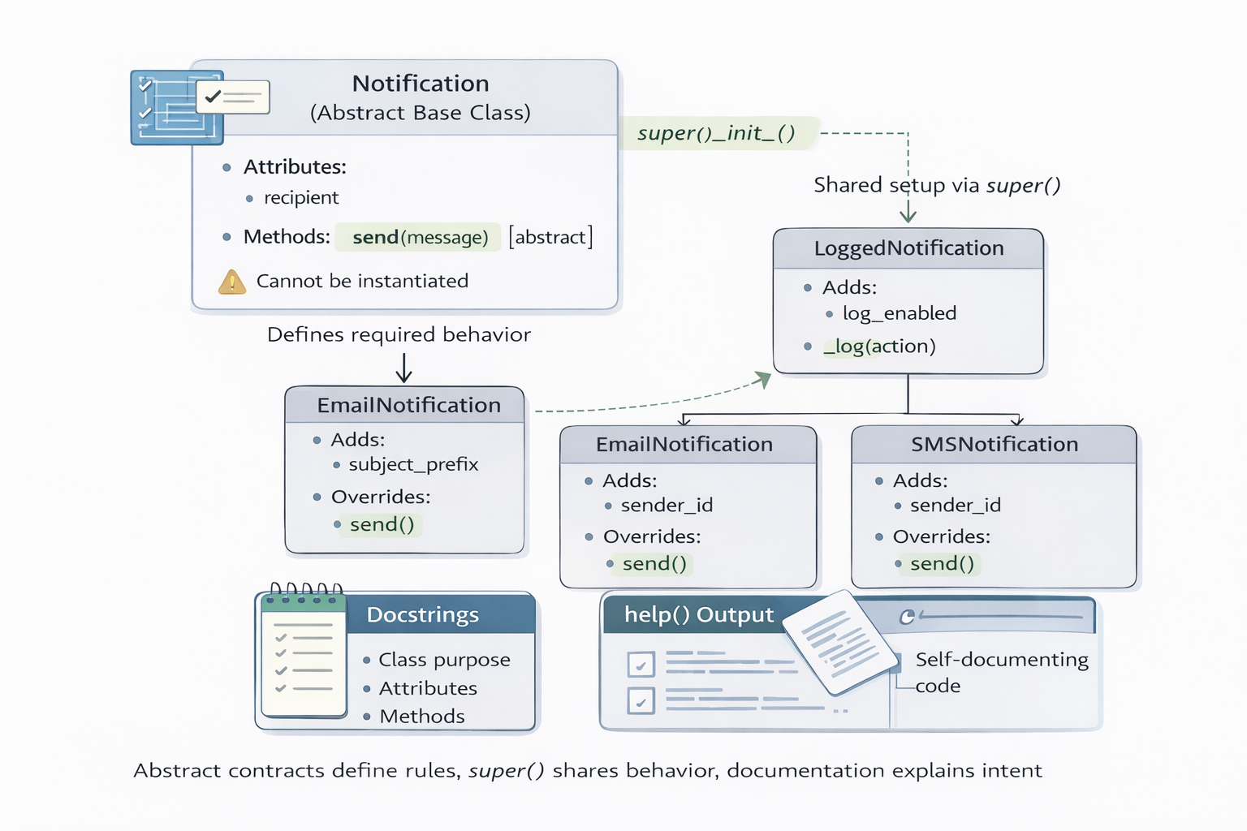

Deliverable
Create one file:
lab_abc_super_docstrings.py
Run:
python lab_abc_super_docstrings.py

Lab Scenario — Notification System
You are building a Notification System for an application.
Supported notification types:
- Email
- SMS
Rules:
- All notifications must follow the same contract (send)
- All notifications share common setup logic (super())

Part 1 — Create an Abstract Base Class (ABC)

Step 1 — Create Notification (ABC)
from abc import ABC, abstractmethod

class Notification(ABC):
"""
Base abstract notification type.

Attributes:
recipient (str): Target user identifier (email or phone).

Methods:
send(message: str) -> None
Send a message to the recipient.
"""

def __init__(self, recipient: str):
self.recipient = recipient

@abstractmethod
def send(self, message: str) -> None:
"""
Send a message to the recipient.

Args:
message (str): Message content.
"""
pass

Checkpoint
This must fail:

# n = Notification("test@example.com") # TypeError (correct behavior)

Part 2 — Use super() Correctly in Subclasses

Step 2 — Implement EmailNotification

class EmailNotification(Notification):
"""
Email notification implementation.

Attributes:
subject_prefix (str): Prefix added to email subject.
"""

def __init__(self, recipient: str, subject_prefix: str = "[APP]"):
super().__init__(recipient)
self.subject_prefix = subject_prefix

def send(self, message: str) -> None:
"""
Send an email notification.

Args:
message (str): Email message content.
"""
print(
f"[EMAIL] To: {self.recipient} | "
f"Subject: {self.subject_prefix} Update | "
f"Message: {message}"
)

Step 3 — Implement SMSNotification

class SMSNotification(Notification):
"""
SMS notification implementation.

Attributes:
sender_id (str): SMS sender identifier.
"""

def __init__(self, recipient: str, sender_id: str = "APP123"):
super().__init__(recipient)
self.sender_id = sender_id

def send(self, message: str) -> None:
"""
Send an SMS notification.

Args:
message (str): SMS message content.
"""
print(
f"[SMS] From: {self.sender_id} -> "
f"{self.recipient} | Message: {message}"
)

Checkpoint
This must now work:
email = EmailNotification("test@example.com")
sms = SMSNotification("+60123456789")

email.send("Hello")
sms.send("Hello")

Part 3 — Add Logging with Correct super() Chaining

Step 4 — Create LoggedNotification

class LoggedNotification(Notification):
"""
Intermediate notification class with logging support.

Attributes:
log_enabled (bool): Enable or disable logging.
"""

def __init__(self, recipient: str, log_enabled: bool = True):
super().__init__(recipient)
self.log_enabled = log_enabled

def _log(self, action: str) -> None:
"""
Log an action if logging is enabled.

Args:
action (str): Action description.
"""
if self.log_enabled:
print(f"[LOG] {action} -> {self.recipient}")

Step 5 — Update Email & SMS to Use Logging
Replace your earlier classes with these versions.

Logged Email

class EmailNotification(LoggedNotification):
"""
Email notification with logging support.
"""

def __init__(self, recipient: str, subject_prefix: str = "[APP]"):
super().__init__(recipient)
self.subject_prefix = subject_prefix

def send(self, message: str) -> None:
self._log("Sending email")
print(
f"[EMAIL] To: {self.recipient} | "
f"Subject: {self.subject_prefix} Update | "
f"Message: {message}"
)

Logged SMS

class SMSNotification(LoggedNotification):
"""
SMS notification with logging support.
"""

def __init__(self, recipient: str, sender_id: str = "APP123"):
super().__init__(recipient)
self.sender_id = sender_id

def send(self, message: str) -> None:
self._log("Sending SMS")
print(
f"[SMS] From: {self.sender_id} -> "
f"{self.recipient} | Message: {message}"
)

Expected Output

[LOG] Sending email -> test@example.com
[EMAIL] To: test@example.com | Subject: [APP] Update | Message: Hello

Part 4 — Reusable Class Documentation (Docstrings)
Already completed:
- All classes have docstrings
- Key methods (send, _log) have docstrings
- Docstrings follow a reusable, professional format

Part 5 — Verify Documentation with help()

Step 6 — Final Test Script

def main():
email = EmailNotification("test@example.com", subject_prefix="[TRAINING]")
sms = SMSNotification("+60123456789", sender_id="PYAPP")

email.send("Welcome to OOP!")
sms.send("Your OTP is 123456")

print("\n--- Documentation Preview ---\n")
help(Notification)
help(EmailNotification)
help(SMSNotification)

if __name__ == "__main__":
main()

What You Should See
- Logging output
- Email & SMS messages
- help() output showing:
  - Class purpose
  - Attributes
  - Methods
  - Docstrings

Final Submission Checklist
The file lab_abc_super_docstrings.py must contain:
- Notification as an ABC
- Correct super() usage
- Logging via intermediate class
- Email & SMS implementations
- Class + method docstrings
- help() output works

Optional Extensions
- Add PushNotification

class PushNotification(LoggedNotification):
"""
Push notification with logging support.

Attributes:
app_name (str): Name of the app shown in push notifications.
"""

def __init__(self, recipient: str, app_name: str = "MyApp"):
super().__init__(recipient)
self.app_name = app_name

def send(self, message: str) -> None:
"""
Send a push notification.

Args:
message (str): Push message content.
"""
self._log("Sending push notification")
print(
f"[PUSH] App: {self.app_name} -> "
f"{self.recipient} | Message: {message}"
)

- Add recipient validation

def __init__(self, recipient: str):
if not isinstance(recipient, str) or not recipient.strip():
raise ValueError("recipient must be a non-empty string")
self.recipient = recipient.strip()

- Add NotificationFactory

class NotificationFactory:
"""
Factory for creating notification objects by type.

Supported types:
- "email"
- "sms"
- "push"
"""

@staticmethod
def create(notification_type: str, recipient: str, **kwargs) -> Notification:
t = notification_type.strip().lower()

if t == "email":
return EmailNotification(
recipient,
subject_prefix=kwargs.get("subject_prefix", "[APP]")
)

if t == "sms":
return SMSNotification(
recipient,
sender_id=kwargs.get("sender_id", "APP123")
)

if t == "push":
return PushNotification(
recipient,
app_name=kwargs.get("app_name", "MyApp")
)

raise ValueError(f"Unsupported notification_type: {notification_type}")

def main():
# Factory-based creation (tests validation too)
email = NotificationFactory.create(
"email",
"test@example.com",
subject_prefix="[TRAINING]"
)
sms = NotificationFactory.create(
"sms",
"+60123456789",
sender_id="PYAPP"
)
push = NotificationFactory.create(
"push",
"user_aina_device_token",
app_name="OOPTrainer"
)

email.send("Welcome to OOP!")
sms.send("Your OTP is 123456")
push.send("You have a new message!")

print("\n--- Documentation Preview ---\n")
help(Notification)
help(EmailNotification)
help(SMSNotification)
help(PushNotification)
help(NotificationFactory)

if __name__ == "__main__":
main()

Conclusion
- Abstract Base Classes enforce design contracts: Using ABC and @abstractmethod ensured all notification types implemented the required send() method, preventing incomplete or incorrect subclasses.
- super() enables safe and scalable inheritance: Proper use of super() allowed shared initialization and behavior (such as logging) to be reused across inheritance chains without duplication.
- Intermediate base classes simplify cross-cutting concerns: Introducing LoggedNotification demonstrated how shared features like logging can be added cleanly without modifying every concrete subclass.
- Docstrings make classes self-documenting: Writing structured class and method docstrings, and verifying them with help(), showed how Python code can explain itself to both users and developers.
- Well-designed OOP systems are easy to extend: Adding new notification types and a factory required minimal changes, highlighting how good abstraction supports long-term maintainability.

Lab 5 : Custom Containers + Iteration + Comparisons

Learning Goals
By the end of this lab, you will be able to:
- Create a custom container class
- Implement the iteration protocol (__iter__)
- Support indexing (__getitem__) and length (__len__)
- Override comparison operators (__eq__, __lt__) so objects can be compared/sorted

Setup
Create one file:
lab_custom_container.py
Run:
python lab_custom_container.py

Part 1 — Build a Custom Container Class

Step 1: Create ScoreList (a container of scores)
Requirements
- Store values internally in a list called _scores
- Provide:
  - add(score) to append
  - __len__() so len(obj) works
  - __getitem__(index) so indexing/slicing works
  - __iter__() so for x in obj works

class ScoreList:
def __init__(self, scores=None):
self._scores = list(scores or [])

def add(self, score):
self._scores.append(score)

def __len__(self):
return len(self._scores)

def __getitem__(self, index):
return self._scores[index] # supports int and slice

def __iter__(self):
return iter(self._scores)

Step 2: Test container behavior

scores = ScoreList([80, 90, 85])
scores.add(70)

print("Length:", len(scores)) # 4
print("Index 1:", scores[1]) # 90
print("Slice 0:2:", scores[0:2]) # [80, 90]

print("Iterate:")
for s in scores:
print("-", s)
Expected behavior:
- len(scores) returns 4
- scores[1] returns 90
- loop prints all scores

Part 2 — Make Objects Comparable
Now we create a container that can be compared and sorted.

Step 3: Create StudentScores with comparisons
Scenario
Each student has:
- name
- scores (ScoreList)
Comparison Rules
- Students are compared by average score
- Support:
  - == using __eq__
  - < using __lt__ (so sorting works)

class StudentScores:
def __init__(self, name, scores):
self.name = name
self.scores = ScoreList(scores)

def average(self):
if len(self.scores) == 0:
return 0.0
return sum(self.scores) / len(self.scores)

def __eq__(self, other):
if not isinstance(other, StudentScores):
return NotImplemented
return self.average() == other.average()

def __lt__(self, other):
if not isinstance(other, StudentScores):
return NotImplemented
return self.average() < other.average()

def __repr__(self):
return f"StudentScores(name='{self.name}', avg={self.average():.2f})"

Step 4: Test comparisons and sorting

s1 = StudentScores("Aina", [90, 85, 95])
s2 = StudentScores("Ali", [70, 75, 80])
s3 = StudentScores("Mira", [90, 85, 95])

print("Aina avg:", s1.average())
print("Ali avg:", s2.average())

print("Equality check (Aina == Mira):", s1 == s3) # True
print("Less-than check (Ali < Aina):", s2 < s1) # True

students = [s1, s2, s3]
print("Sorted students:", sorted(students))
Expected behavior:
- s1 == s3 is True
- s2 < s1 is True
- sorting places Ali first (lowest average)

Final Program (main)

Step 5: Combine into main()

def main():
# Part 1: Container tests
scores = ScoreList([80, 90, 85])
scores.add(70)

print("Length:", len(scores))
print("Index 1:", scores[1])
print("Slice 0:2:", scores[0:2])

print("Iterate:")
for s in scores:
print("-", s)

print("\n" + "-" * 40 + "\n")

# Part 2: Comparison tests
s1 = StudentScores("Aina", [90, 85, 95])
s2 = StudentScores("Ali", [70, 75, 80])
s3 = StudentScores("Mira", [90, 85, 95])

print("Equality check (Aina == Mira):", s1 == s3)
print("Less-than check (Ali < Aina):", s2 < s1)

students = [s1, s2, s3]
print("Sorted students:", sorted(students))

if __name__ == "__main__":
main()

Submission Checklist
Students submit lab_custom_container.py containing:
- ScoreList with __len__, __getitem__, __iter__
- StudentScores with __eq__, __lt__
- Tests showing:
  - indexing & slicing works
  - iteration works
  - sorting works

Optional Extensions
- Add __contains__ so 90 in scores works

def __contains__(self, value):
return value in self._scores

print("\nMembership test:")
print("90 in scores?", 90 in scores)
print("50 in scores?", 50 in scores)

- Add top(n) method to return top N scores
def top(self, n=1):
if n <= 0:
raise ValueError("n must be positive")
return sorted(self._scores, reverse=True)[:n]

print("\nTop scores:")
print("Top 1:", scores.top(1))
print("Top 2:", scores.top(2))

- Add __bool__ so empty ScoreList is False
# 2) Boolean behavior: empty container = False
def __bool__(self):
return len(self._scores) > 0

print("\nBoolean behavior:")
empty_scores = ScoreList()
print("bool(scores):", bool(scores))
print("bool(empty_scores):", bool(empty_scores))

- Add validation (scores must be 0–100)

# 4) Validation helper
def _validate(self, score):
if not isinstance(score, (int, float)):
raise TypeError("score must be a number")
if not 0 <= score <= 100:
raise ValueError("score must be between 0 and 100")

print("\nValidation tests:")
try:
scores.add(150)
except ValueError as e:
print("Error:", e)

try:
scores.add("A")
except TypeError as e:
print("Error:", e)

Key Takeaways
- Custom containers can behave like built-in Python types
By implementing __len__, __getitem__, and __iter__, your own classes can support len(), indexing, slicing, and for loops naturally.
- The iteration protocol enables clean, Pythonic APIs
Implementing __iter__ allows objects to integrate seamlessly with loops, sum(), sorting, and other standard Python features.
- Operator overloading makes domain objects comparable and sortable
Defining __eq__ and __lt__ lets complex objects (like students with scores) be compared using meaningful business logic.
- Encapsulation improves safety and correctness
Adding validation, truthiness (__bool__), and membership checks (__contains__) helps protect internal state and prevent invalid data.
- Well-designed containers are easy to extend without breaking code
Optional features like top(n) and input validation show how a clean class design supports growth while remaining readable and maintainable.

Lab 6: Refactor Inheritance → Composition + Add Mix-ins (Logging & Display)

Learning Goals
By the end of this lab, you will be able to:
- Replace an is-a (inheritance) design with a has-a (composition) design
- Add reusable behavior using mix-ins (Logging + Display)
- Keep core classes small and easier to extend
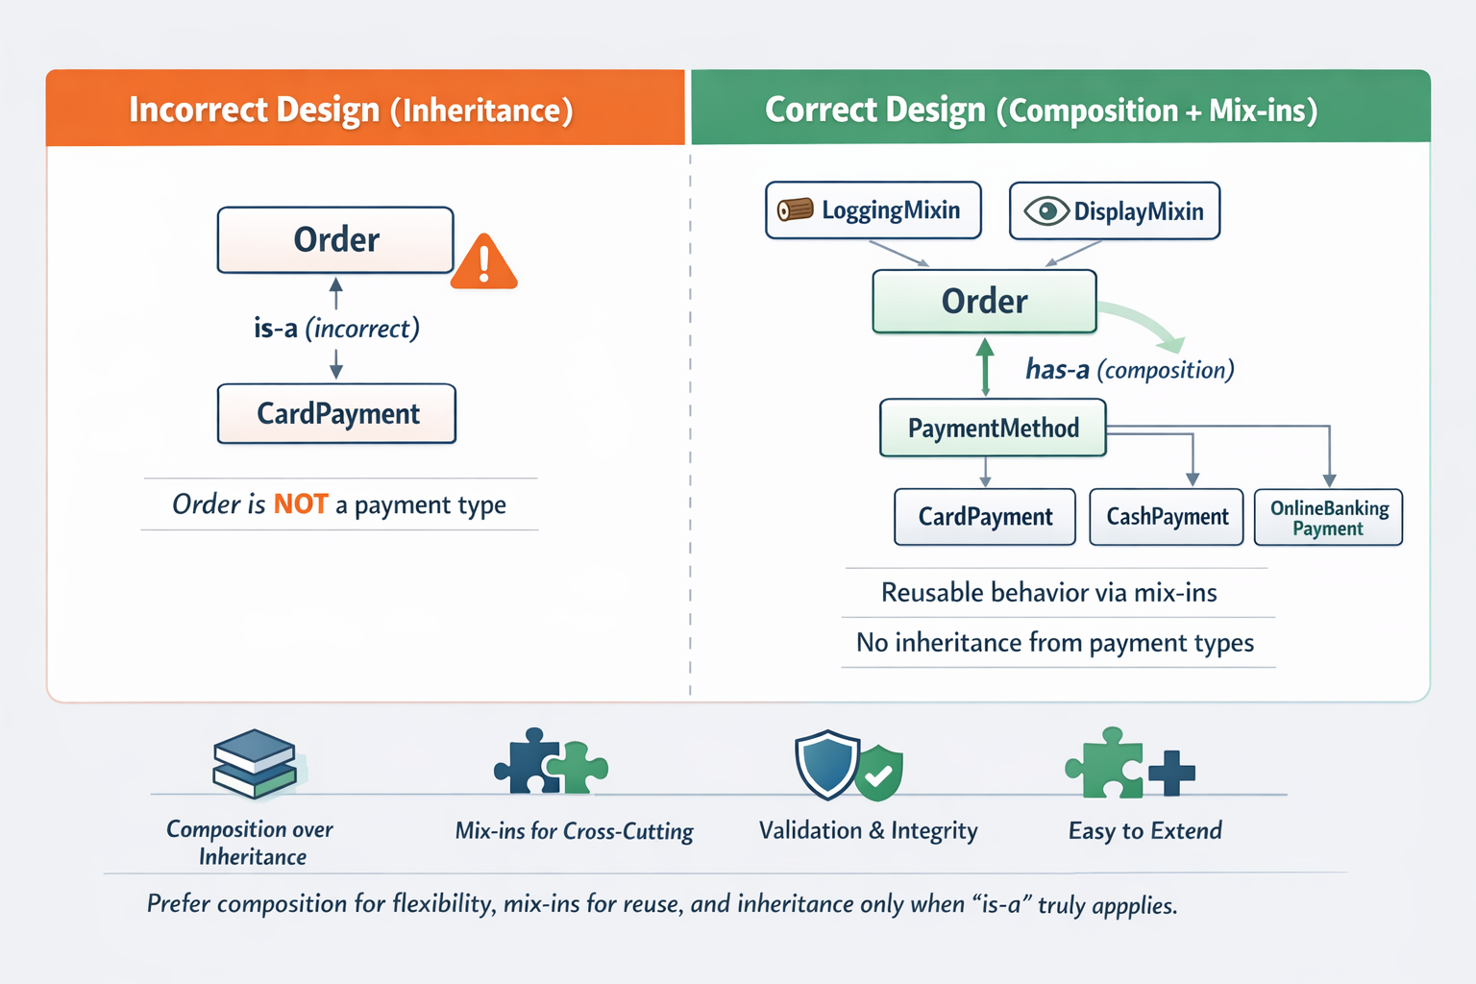

Setup
Create one file:

lab_composition_mixins.py
Run:
python lab_composition_mixins.py

Part 1 — Start with the “Inheritance” Version

Step 1: Paste this starter code (inheritance-heavy design)

class Payment:
def pay(self, amount):
raise NotImplementedError

class CardPayment(Payment):
def pay(self, amount):
print(f"[CARD] Paid {amount}")

class CashPayment(Payment):
def pay(self, amount):
print(f"[CASH] Paid {amount}")

# ❌ Problem: Order inherits from CardPayment even though Order is not a payment type.
class Order(CardPayment):
def __init__(self, order_id, total):
self.order_id = order_id
self.total = total

Step 2: Run a quick test

def test_inheritance_version():
order = Order("O100", 50)
order.pay(order.total) # works, but design is wrong

test_inheritance_version()
Observation
- Order is not a payment method.
- This is a misuse of inheritance.
- We should refactor to composition.

Part 2 — Refactor to Composition (Has-a)

Step 3: Replace inheritance with composition
Task:
Refactor Order so it contains a payment method object instead of inheriting one.
Replace the Order class with this:
class Order:
def __init__(self, order_id, total, payment_method):
self.order_id = order_id
self.total = total
self.payment_method = payment_method # ✅ has-a

def checkout(self):
self.payment_method.pay(self.total)

Step 4: Test composition
def test_composition_version():
order1 = Order("O200", 80, CardPayment())
order2 = Order("O201", 30, CashPayment())

order1.checkout()
order2.checkout()

test_composition_version()

✅ Expected output:
[CARD] Paid 80
[CASH] Paid 30

Part 3 — Implement Mix-ins (Logging + Display)

Step 5: Create a LoggingMixin
Task: Add reusable logging behavior.
class LoggingMixin:
def log(self, message):
print(f"[LOG] {message}")

Step 6: Create a DisplayMixin
Task: Add reusable “display object state” behavior.

class DisplayMixin:
def display(self):
attrs = vars(self)
return f"{self.__class__.__name__}({attrs})"

Part 4 — Apply Mix-ins to the Composed Class

Step 7: Update Order to use mix-ins
Replace your Order class with this mix-in version:

class Order(LoggingMixin, DisplayMixin):
def __init__(self, order_id, total, payment_method):
self.order_id = order_id
self.total = total
self.payment_method = payment_method

def checkout(self):
self.log(f"Checkout started: {self.order_id}")
self.payment_method.pay(self.total)
self.log(f"Checkout completed: {self.order_id}")

Step 8: Test mix-ins

def test_mixins():
order = Order("O300", 120, CardPayment())
print(order.display())
order.checkout()

test_mixins()
Expected output (example):

Order({'order_id': 'O300', 'total': 120, 'payment_method': <__main__.CardPayment object at ...>})
[LOG] Checkout started: O300
[CARD] Paid 120
[LOG] Checkout completed: O300

Submission Checklist
Your lab_composition_mixins.py must include:
- Payment, CardPayment, CashPayment
- Order refactored to composition (payment_method attribute)
- LoggingMixin and DisplayMixin
- Order uses both mix-ins
- A working test run showing:
  - payment works via composition
  - logging prints before/after checkout
  - display prints object state

Optional Extensions (If Time Allows)
- Add OnlineBankingPayment(Payment) without changing Order
class OnlineBankingPayment(Payment):
def pay(self, amount):
print(f"[ONLINE BANKING] Paid {amount}")

- Improve DisplayMixin so it prints payment type cleanly
class DisplayMixin:
def display(self):
attrs = {}

for key, value in vars(self).items():
if key == "payment_method":
attrs[key] = value.__class__.__name__
else:
attrs[key] = value

return f"{self.__class__.__name__}({attrs})"

- Add validation: total > 0 in Order.__init__
class Order(LoggingMixin, DisplayMixin):
def __init__(self, order_id, total, payment_method):
if total <= 0:
raise ValueError("Order total must be greater than 0")

self.order_id = order_id
self.total = total
self.payment_method = payment_method

def checkout(self):
self.log(f"Checkout started: {self.order_id}")
self.payment_method.pay(self.total)
self.log(f"Checkout completed: {self.order_id}")

print("\n--- Validation Test ---")
try:
Order("O402", -10, CashPayment())
except ValueError as e:
print("Error:", e)

Key takeaways
- Composition enables easy extension without touching existing classes
- Mix-ins add cross-cutting behavior cleanly
- Validation protects object integrity
- This design scales naturally to real systems (payments, orders, plugins)

